CSA5103-Cryptography And Network Security
Experiment 1
Aim:
To write a Python program to implement the Caesar Cipher, which encrypts and decrypts a message by shifting each letter by a fixed number of positions.
Algorithm:
- Start the program.
- Read the plaintext message from the user.
- Read the shift value (k) from the user.
- For each character in the plaintext:
  - If it is an alphabet, shift it by k positions.
  - Use modulo (% 26) to wrap around after Z.
  - Keep spaces and special characters unchanged.
- Display the encrypted message.
- Decrypt the ciphertext by shifting each letter k positions backward.
- Display the original plaintext.
- Stop the program.
Code:
# Caesar Cipher Encryption and Decryption
def caesar_encrypt(text, k):
result = ""
for char in text:
if char.isalpha():
if char.isupper():
result += chr((ord(char) - ord('A') + k) % 26 + ord('A'))
else:
result += chr((ord(char) - ord('a') + k) % 26 + ord('a'))
else:
result += char
return result
def caesar_decrypt(text, k):
result = ""
for char in text:
if char.isalpha():
if char.isupper():
result += chr((ord(char) - ord('A') - k) % 26 + ord('A'))
else:
result += chr((ord(char) - ord('a') - k) % 26 + ord('a'))
else:
result += char
return result
# Main Program
plaintext = input("Enter the plaintext: ")
k = int(input("Enter the shift value (1-25): "))
ciphertext = caesar_encrypt(plaintext, k)
print("Encrypted Text:", ciphertext)
decrypted = caesar_decrypt(ciphertext, k)
print("Decrypted Text:", decrypted)
Output:
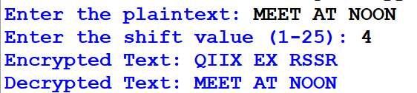
Result:
Thus, the Python program for the Caesar Cipher was implemented successfully, and the plaintext was encrypted and decrypted correctly using the given shift value.

